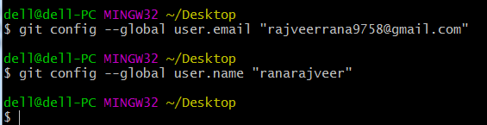

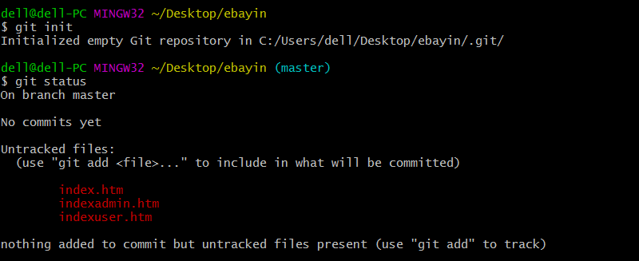



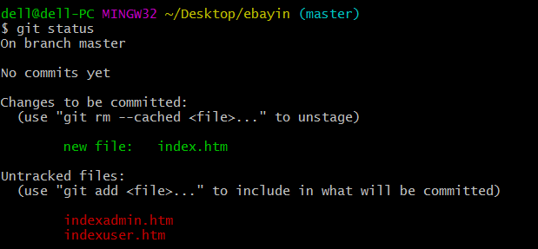

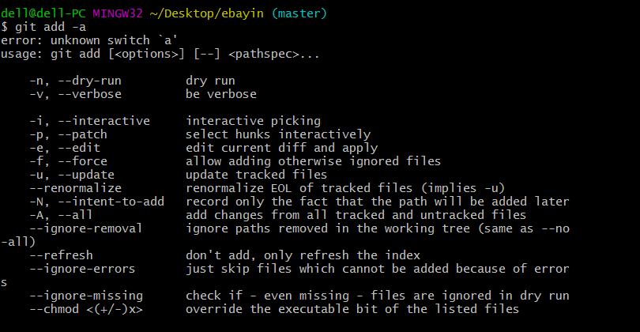

To add all files into git which are staging area.



Here you can see the files which are staged in staging area so that right now after the execution of the command.

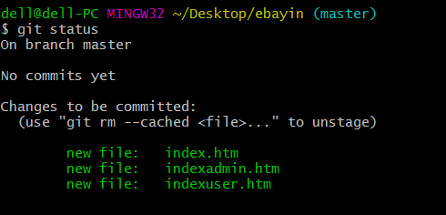

To remove a file from staging area

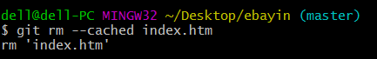

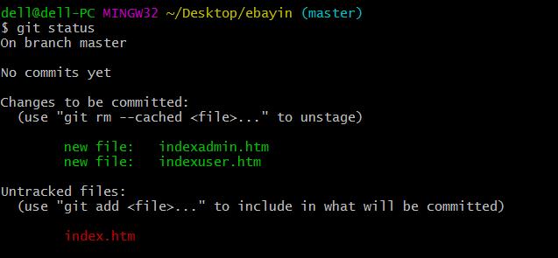

To create snapshot for last updated file like it is savepoint

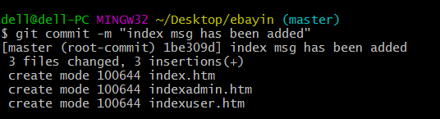

To link local repository to remote repository



To pull local files to remote repository

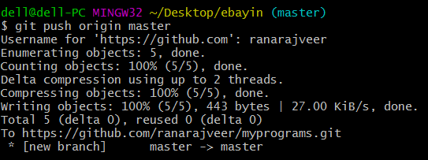

just create a user folder on desktop then right click on git bash then type

command $git clone <https://githhub.com/ranarajveer/myprograms.git>

this will create myprograms folder under user folder on desktop.

